RAM Drive

RAM Drive is a package of 4 utilities for virtual drive handling.

ramdrive

RAM Drive driver

This driver emulates virtual disk-it maps it into the conventional MB-02+ backed up memory. By installing this driver a new drive #09 is added into the system. RAM Drive behaves in exactly the same way as a typical floppy drive; you can even treat it the same way-utilities such as di, cdd, fi, lendir etc. work perfectly with RAM Drive. You can even format it using ff17!

Installation

It is assumed that BS-DOS 199 or later is booted.
There is a small header at the beginning of the driver file. This header contains the port address and numbers of memory banks specifying the memory area available for RAM Drive (memory bank=16384 bytes (16K)). It looks as follows:

org #32768
jr install ;jump at the installation routine
port defb 23 ;the port address for memory swapping
dos_bnk defb 97 ;the memory bank with BS-DOS
dat_bnk defb 98,99,100,101,102,103 ;memory banks for RAM Drive usage (96
(%1100000) added to each bank number-
enables SRAM with writing; banks 0&1 are
used by BS-DOS)
defb 0,0,0,0... ;unused

But you do not have to bother yourself by modifying ramdrive utility. We strongly recommend to use ramdrvcfg program which reliably configures ramdrive for you. All you have to do is assign all memory banks that will be used by ramdrive-the more banks you assign the more space you get on your virtual RAM Drive. Not assigned banks will remain untouched.
Once you create configured ramdrive driver using ramdrvcfg, save it to a floppy from which you usually boot your system (it is recommended that you delete any existing ramdrive file from directory 0 before saving the new one). Once this has been accomplished, put <NEW "ramdrive"> command into your autoexe file to make sure your RAM Drive is always installed with your system's boot procedure. Before you can use RAM Drive for the first time, you must format it. Use ff17 utility to do so:

name=RAMDRIVE
drv=9
hdd=0
trk=16
sec=15
As you can see, RAM Drive basically emulates doublesided floppy with 16 tracks and 15 sectors/track in our example.
Note that trk number specifies the number of memory banks assigned to RAM Drive. Maximum RAM Drive capacity is obvious from the table that follows:
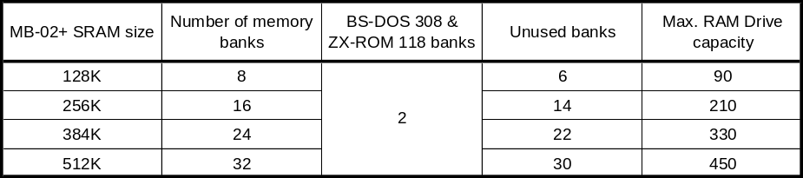

Parameter sec specifies the numbers of sectors per track (=memory bank). Even though there are 16K (sectors) in each memory bank 1 track is missing due to the need for some file allocation structures. That is why we have 15K per track (=memory bank).

ramdinit
smart RAM Drive initialisation

This utility scans all 255 drives in the system and looks for the RAM Drive.
If no virtual drive is detected, ramdinit is terminated.
If there is a RAM Drive installed in your system, it is tested for existing data structures. If it detects that the RAM Drive was installed for the first time and was not formatted, it does it for you (so that you do not have to use ff17).
If there are data on your RAM Drive, it tests the data consistency. If it detects that data is corrupted (due to e. g. battery replacement), the RAM Drive is formatted. Otherwise ramdinit is terminated.
It is strongly recommended to add <NEW "ramdinit"> command into your autoexe file right after the <NEW "ramdrive" command> (see above).

ramdroff

RAM Drive uninstallation

RAM Drive is completely removed from your system by running this utility.

ramdrvcfg

RAM Drive configuration

Use this utility for easy and comfortable RAM Drive configuration. The usage is described in the Installation section above.

Have fun using RAM Drive!

8BC Ltd. & Busysoft

